Broadcast Algorithm for Binary Directed de Bruijn Networks
Ming-Bo Lin and Ming-Hong Bai
中華民國八十六年全國計算機會議, E-18~E-23
Abstract

This paper presents an optimal one-to-all broadcast algorithm for binary de Bruijn networks with the expected running time 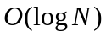, where  is the number of nodes of the network. In addition, an optimal all-to-all broadcast algorithm is proposed.
- Introduction

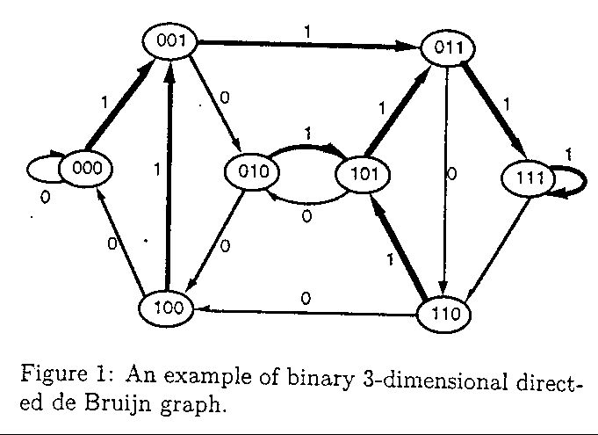

The distance between any two nodes X and Y, denoted as D(X,Y), is defined as the path with minimum number of edges between nodes X and Y. Ex: X=00100 and Y=10011 on the network, then maximum length of suffix of X that matches the prefix of Y is 3, and the distance is 5-3=2,ie D(X,Y)=2 (5-dimension directed de Bruijn network)

Each node on a binary directed de Bruijn network has two outgoing links and two incoming links.
- One-to-All Broadcast Algorithm
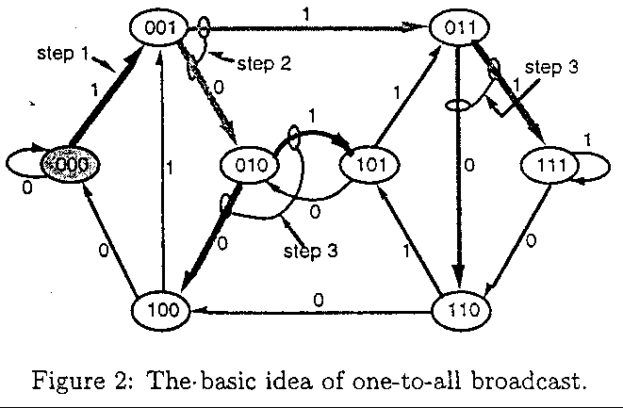

Rule 1: Let X,Y, and Z be any three nodes on a directed de Bruijn network. Assume that Y is the left-child node of X and Z is the right-child node of X. Node R is the source node of a message. The node X distributes its received message M according to the following rules :
- If D(R,X)D(R,Y), then X stop distributing M to Y; otherwise, X distributes M to Y.
- If D(R,X)D(R,Z), then X stop distributing M to Z; otherwise, X distributes M to Z.
- All-to-All Broadcast Algorithm
The basic idea of this algorithm is follows:
For each node on the network, it sends its message to its two outgoing links and then receives messages from its two incoming links. In turn it combines the messages received and prepares for the next step of distributing operation.
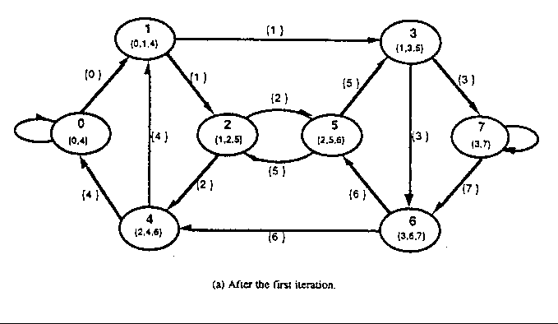
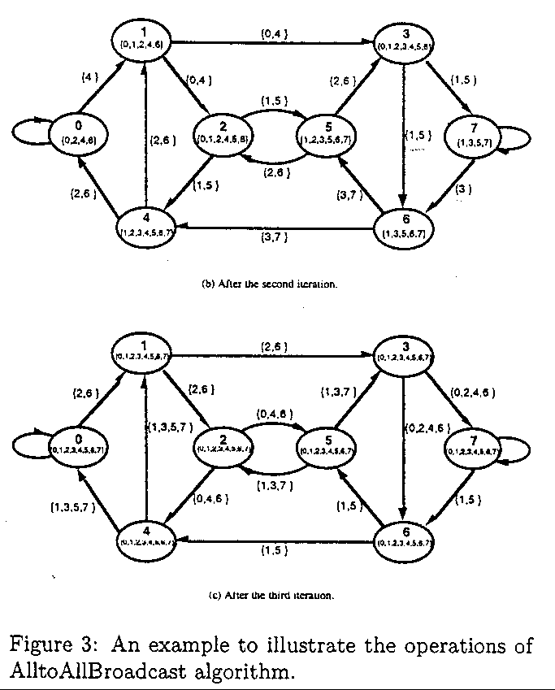
- Conclusion
Created by : Jenn-Dar Chang
Date : Jul.27, 1999

